Wastewater Data – 11/30/23
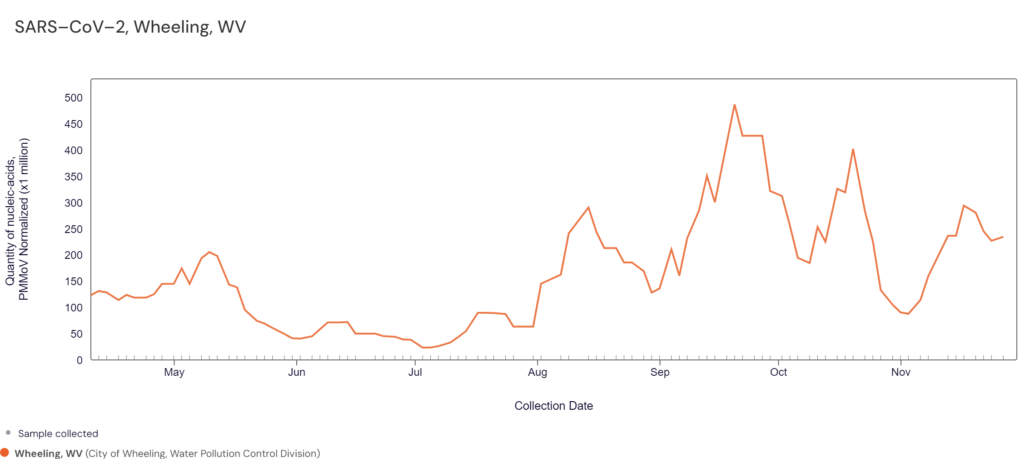
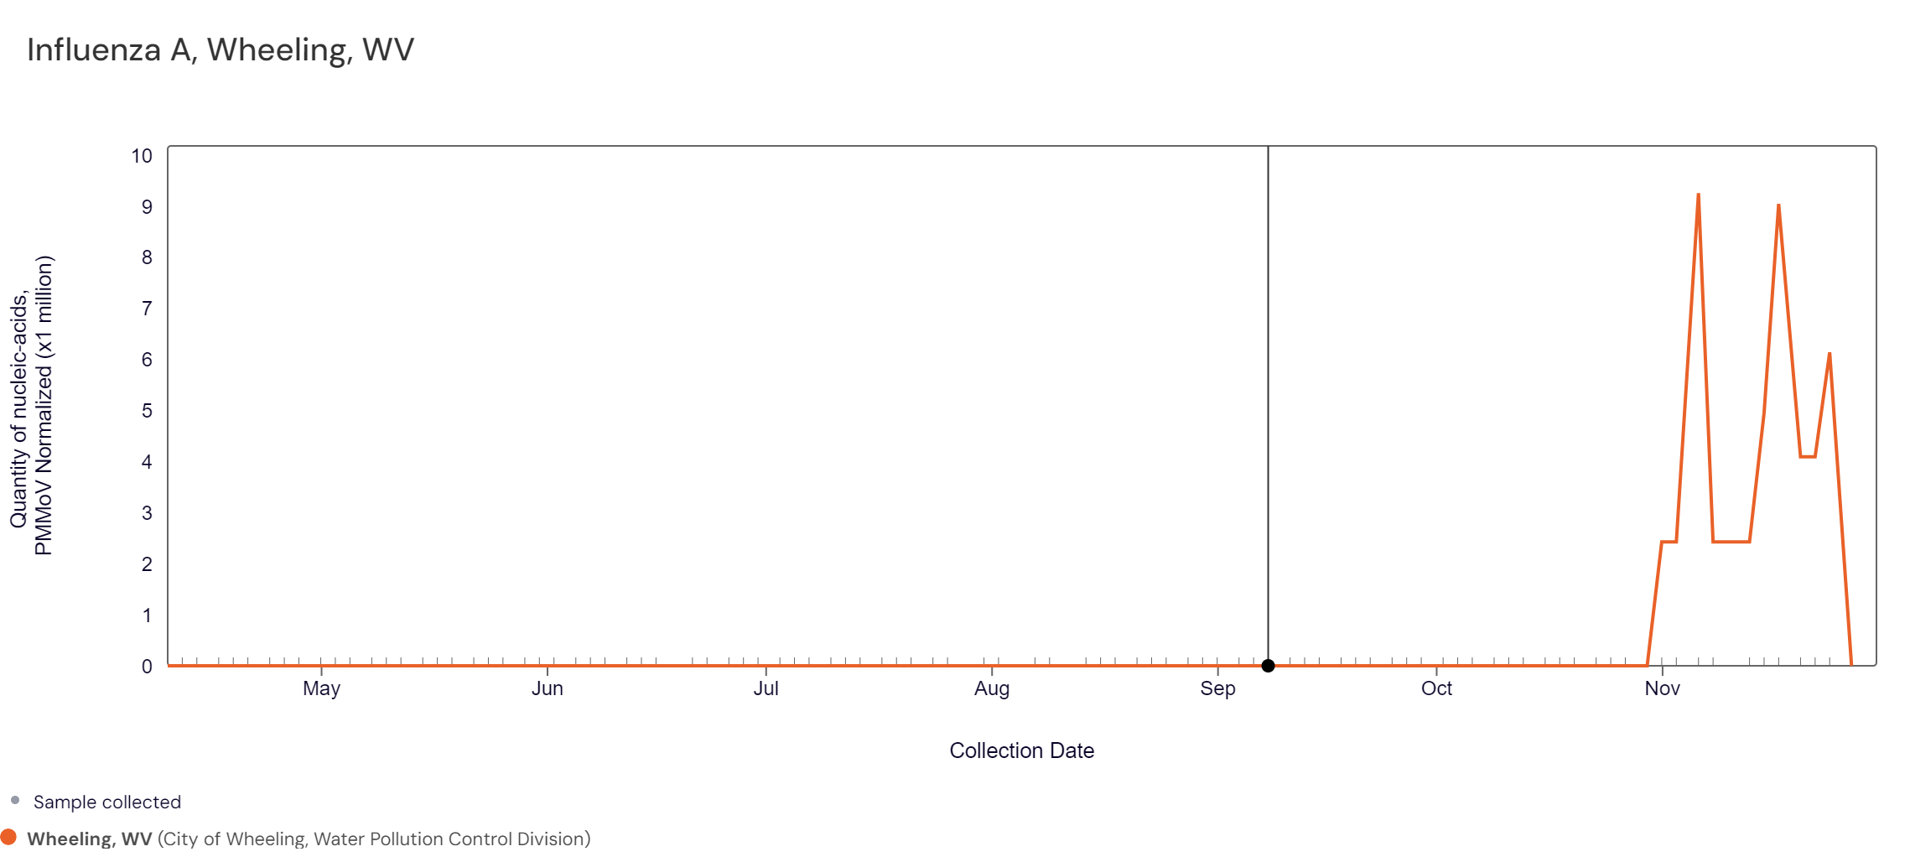
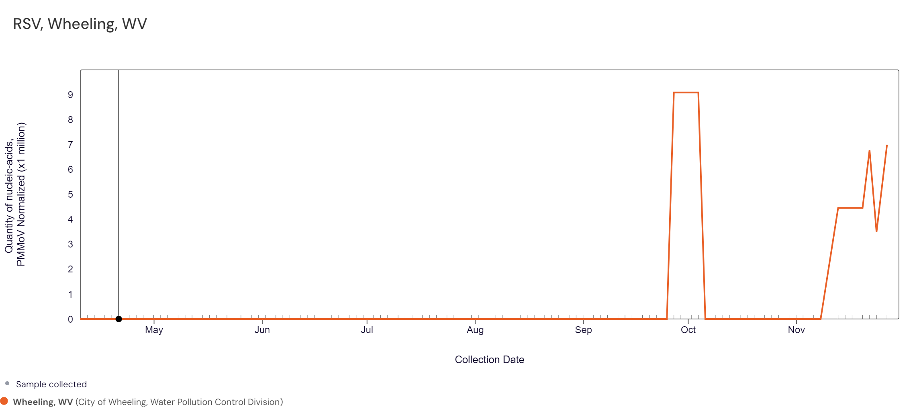
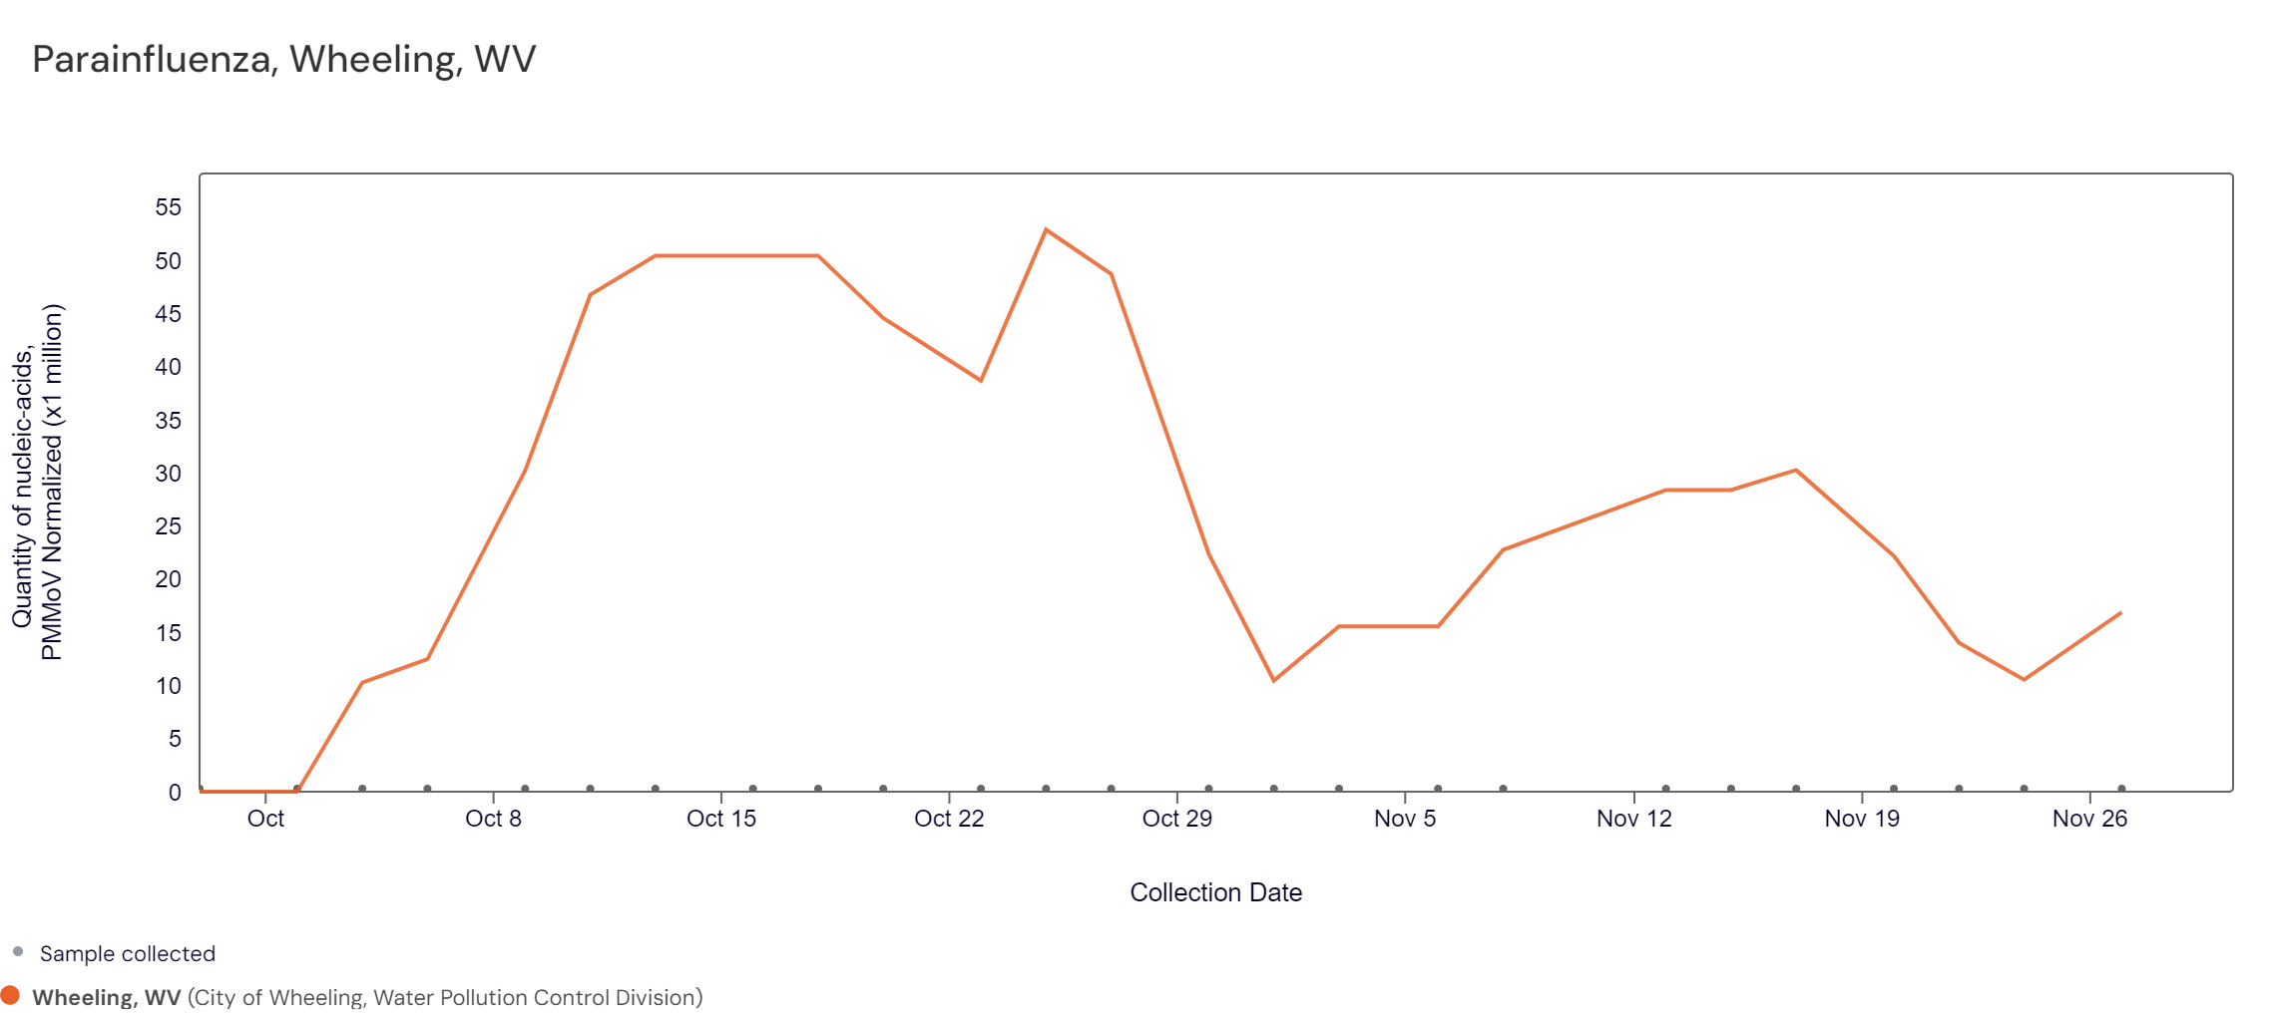
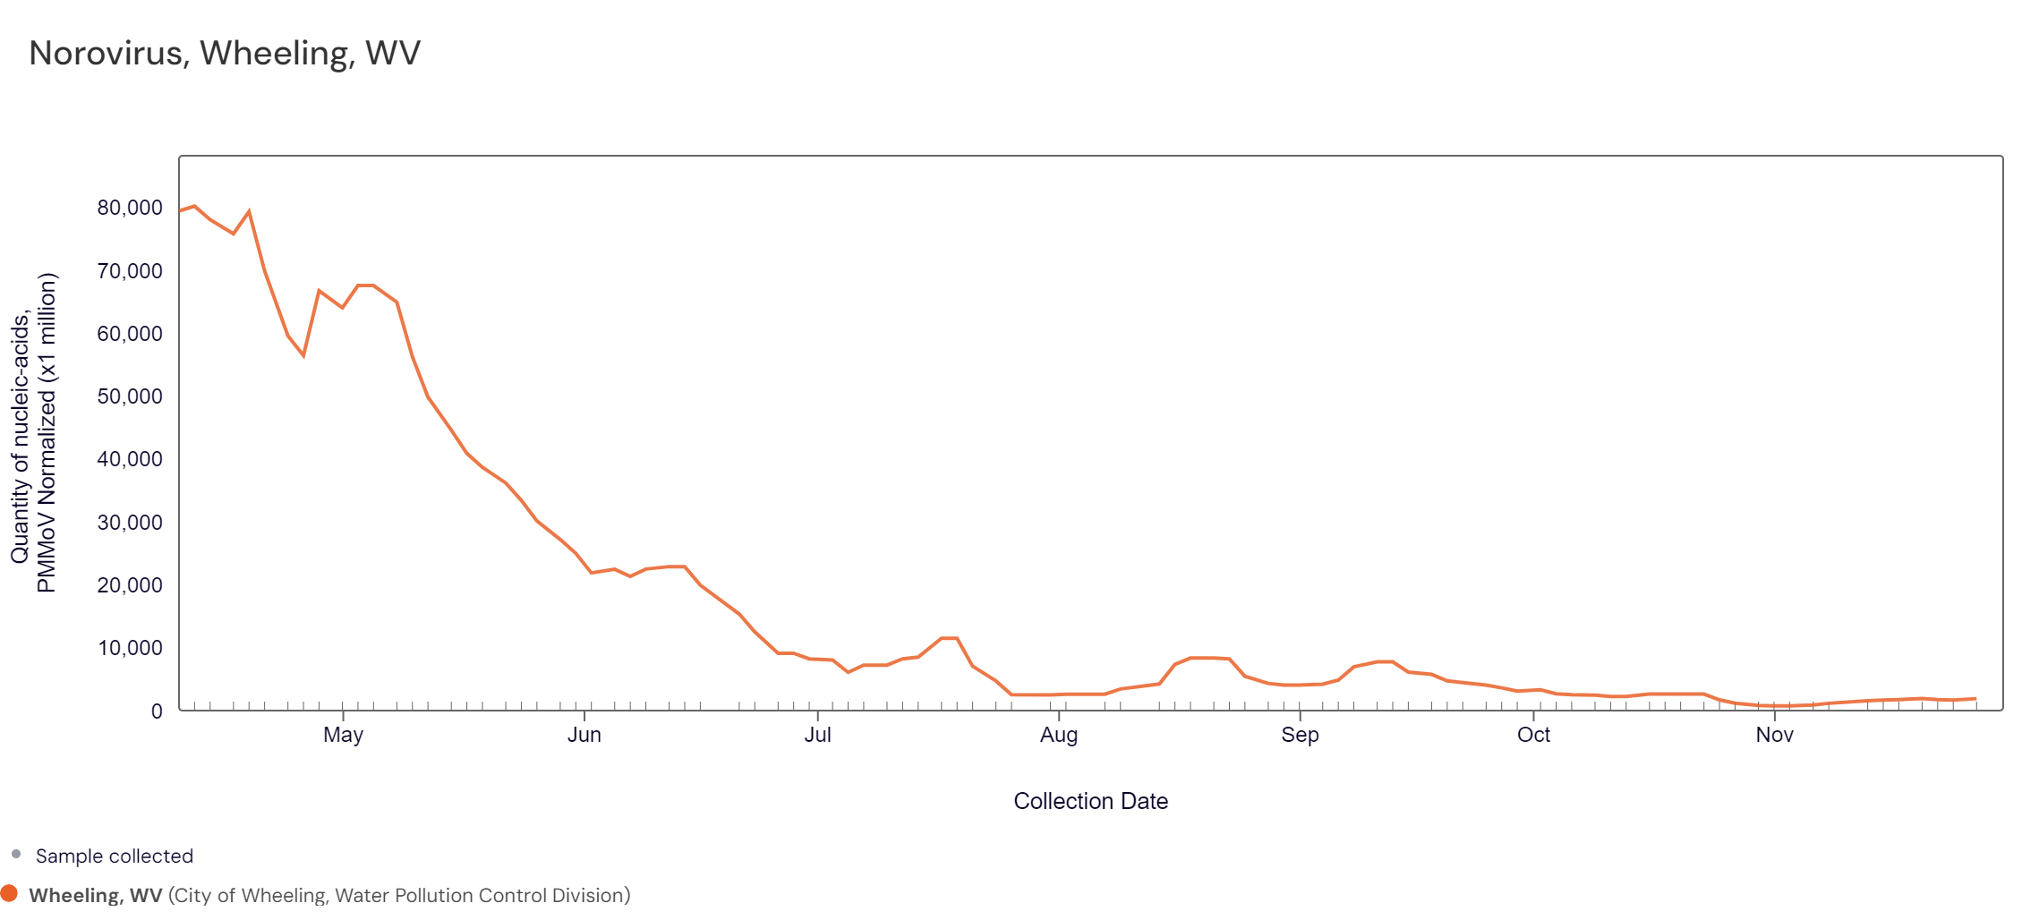
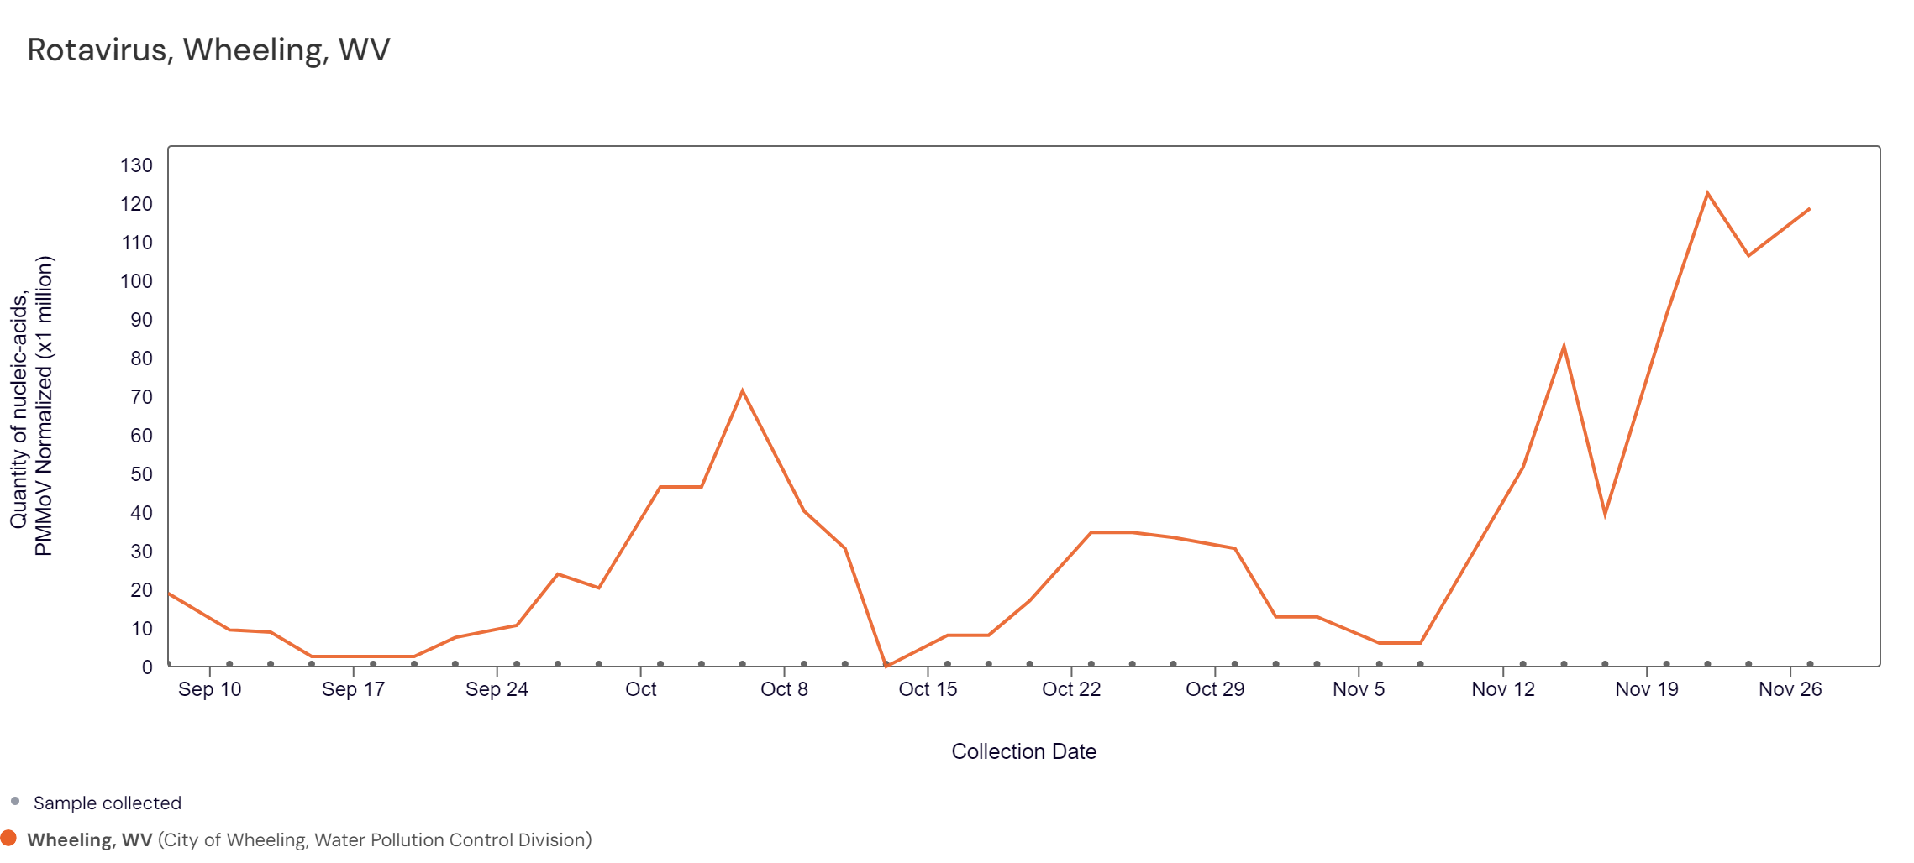
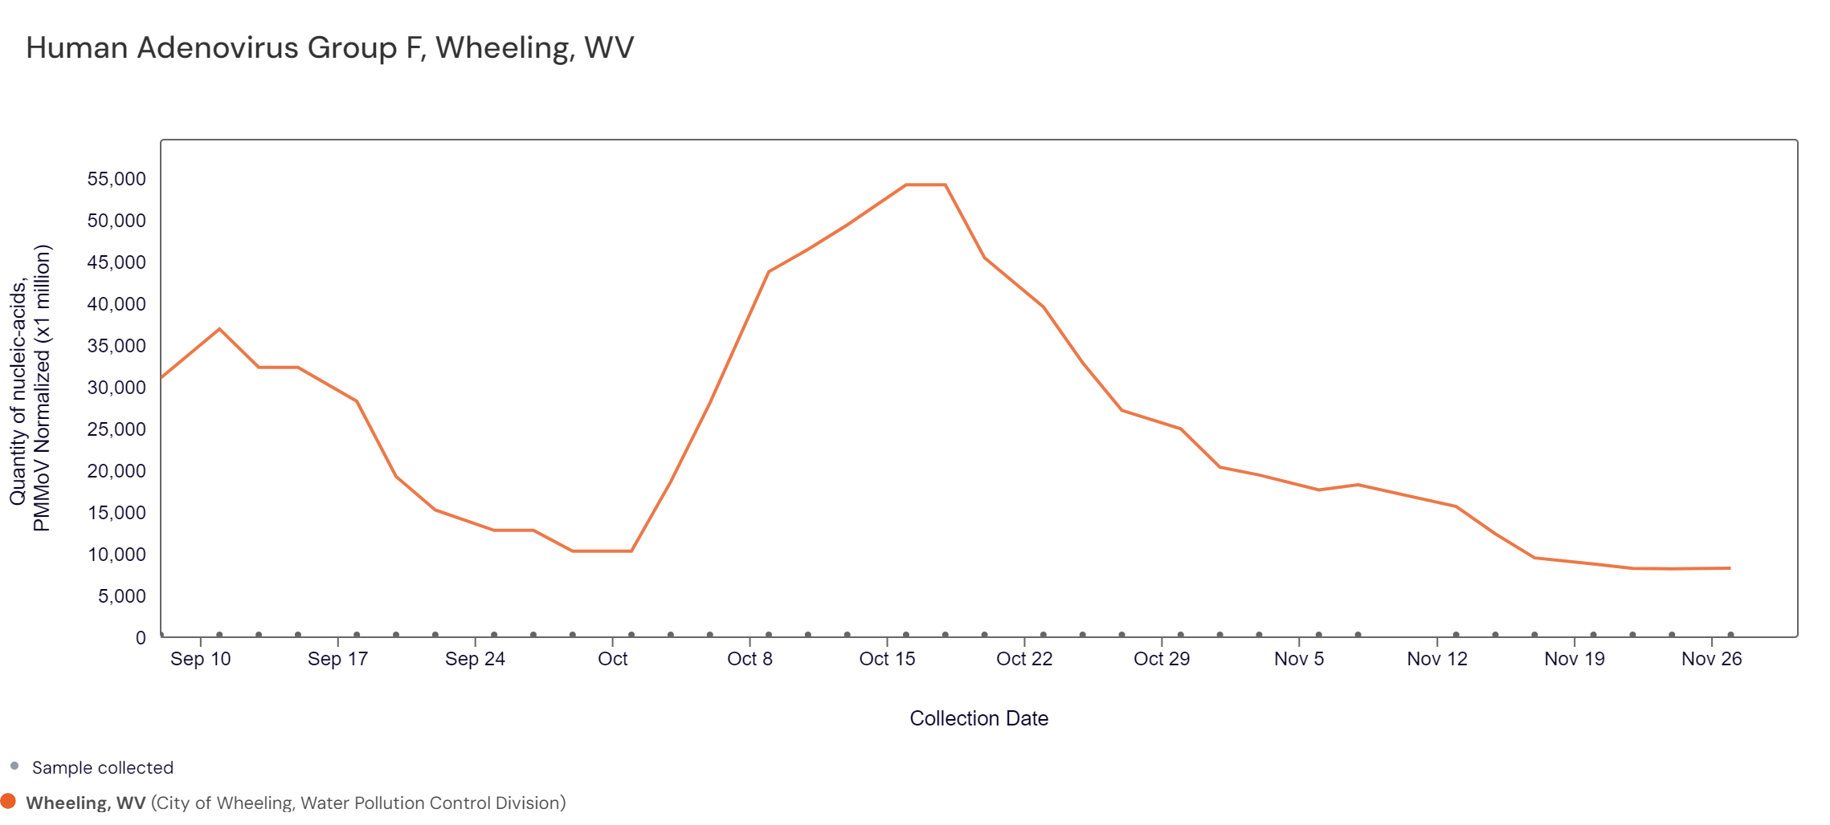

The Wheeling-Ohio County Health Department is reporting that levels of COVID-19 are elevated (Medium) in the local community. Other respiratory issues that are circulating at an elevated level include Respiratory syncytial virus (RSV), Influenza and Parainfluenza. The health department is also reporting that levels of Rotavirus, Norovirus and Human Adenovirus Group F (all gastrointestinal pathogens) are also elevated for Ohio County.
These specific diseases and their identification as elevated in the Ohio County community is made through wastewater surveillance at the City of Wheeling’s Water Treatment Plant. The treatment plant serves most of Ohio County and Benwood.
Wastewater surveillance is the testing of wastewater (also referred to as sewage) to identify contaminants. Wastewater includes water produced by the community from sources such as toilets, showers, and sinks. It can also contain rainwater. Wastewater may contain contaminants like pathogens, chemicals, and sludge. When water is flushed or drained from a building or home, or enters a storm drain, it flows through the community’s sanitary sewage system to a wastewater treatment plant where it is treated to remove contaminants.
Wastewater surveillance is a useful tool for public health professionals to assess community health. Pathogens can enter the wastewater from the stool (poop) of infected people and can be detected and measured. Wastewater surveillance can complement other types of surveillance data, like clinical testing, to inform public health decision making.
When interpreting wastewater data, it is best to assess trends over time and compare those to case-based data and in the context of community level transmission. For example, if SARS-CoV-2 concentrations are increasing, this means that the number of individuals shedding SARS-CoV-2 in their stool is increasing. This could be due to a true increase in individuals with COVID-19 or the movement of ‘new’ individuals in a population e.g., a large sporting event, work conference, etc.
A major advantage of wastewater surveillance is the early warning sign that a pathogen is spreading in a community. This can show if disease levels are increasing or decreasing. The testing does not depend on clinical testing (e.g., people seeking tests, availability of tests, access to healthcare).
Wastewater surveillance cannot accurately determine the number of infected individuals in a community or capture homes on septic systems or facilities served by decentralized systems that treat their own waste.
The City of Wheeling, Wastewater Treatment Plant, participates with the Wastewater SCAN project to test samples of solids from the local wastewater for targets associated with infectious diseases. The concentration of these targets in wastewater is associated with the occurrence of the related disease in the community, and changes in the concentrations of these markers in wastewater over time tell public health about changes in the rates of disease in the community.
A﻿s of September 2023, the program is testing for the following 12 pathogens:
- Respiratory pathogens: SARS-CoV-2 using a conserved target on the N gene, Influenza A (IAV), Influenza B (IBV), Respiratory Syncytial Virus (RSV), Human Metapneumovirus (HMPV), and Enterovirus D68 (EVD68)
- Gastrointestinal pathogens: Norovirus GII, Rotavirus, and Human Adenovirus Group F
- O﻿ther pathogens of concern: Candida auris (C.auris), Hepatitis A (Hep A) and Mpox

